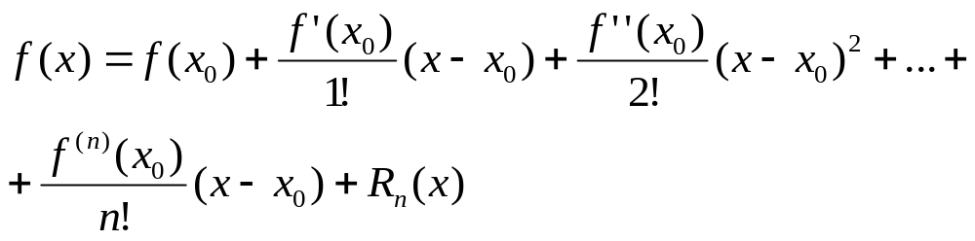

y= (1+x)e^{-x} =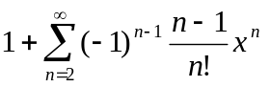=

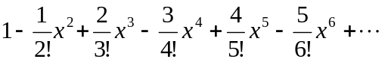

n=1 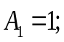
n=2 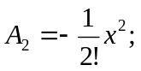
n=3 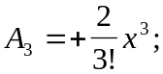
n=4 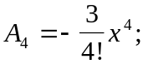
n=5 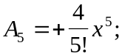
n=6 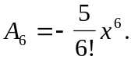

A:= -A*x*(k-1)/(k*(k-2))

Program aaa;
var X, S, Y, A : real;
k : integer;
begin
x:= -6;
while x< 6.25 do
begin
{S iegūst rindas summas vērtību}
y:=(1+x)* Exp(-x);
writeln(x:6:2,S:12,Y:12,k:6);
x:=x+0.5
end
end.

S: =1-0.5*x*x;
A:= -0.5*x*x;
k:=3;
while ABS (A)> 0.0001 do
begin
A:= -A*x*(k-1)/(k*(k-2));
S:=S+A;
k:=k+1
end;

